**Title:** Inter- and intraspecific priority effects upon fruit quality in two mass-flowering berry crops

**Authors:** Liam Kendall1, Jamie R. Stavert1, Vesna Gagic2, Mark Hall1,3 and Romina Rader1

1. School of Environmental and Rural Sciences, University of New England, Armidale, NSW 2351, Australia
2. CSIRO Agriculture, GPO Box 2583, Brisbane, QLD 4001, Australia
3. Western Sydney University

**Abstract**

**Introduction**

The compositional trajectory of ecology communities is often strongly influenced by the order of species arrival to those communities, a phenomenon termed “priority effects” (REF). Priority effects often determine how species interact and compete with each other within communities, and can drive divergent successional trajectories among sites. Priority effects can be mediated by environmental variability (Tucker & Fukami, 2014) and disturbance (Jiang & Patel, 2008), although many causes are still unknown. Environmental viability can influence priority effects through differences and changes in species growth rates among species; species with higher growth rates modify habitats that either hinder or facilitate the establishment of late arriving species through the pre-emption or modification of habitat resources (de Freitas & Frederickson 1978; Tilman 1980; Facelli & Facelli 1993; Loeuille & Leibold, 2008). Importantly, such responses are mediated by each species’ sensitivity to environmental variability (Chesson 2000).

The majority of studies on priority effects have focussed on microbial communities, specifically bacterial and yeast communities that occur in floral nectar (e.g., Peay, Belisle and Fukami 2012; Tucker & Fukami 2014; Toju et al. 2018). However, priority effects are also an important driver of competition among frog species (Alford & Wilbur 1985) and in coral reef fish communities (Shulman et al. 1983; Almany 2003). Interestingly, studies detailing priority effects in floral bacteria communities have shown that floral bacterium can reduce pollination success by reducing pollinator foraging and nectar consumption (Vanette et al. 2013; Good et al. 2014).

Priority effects may influence other pollination-related ecological processes. Animal-mediated pollination is primarily a process governed by floral visitor/pollinator communities, and its species composition, interacting sequentially upon a given plant species (i.e. a floral visitation sequence). In this case, a priority effect may be the result of the behaviour or identity of the first visitor to a flower and this may have important impacts upon measures of pollination success (e.g., fruit set and fruit weight). Further, this effect may also, hypothetically, be mediated by floral morphology (e.g., the presence and location of floral resources and rewards) interacting with pollinator identity and behaviour. As such, these effects likely manifest at both intraspecific and interspecific levels. Previous studies (e.g., Vanette & Fukami 2014) suggest that priority effects may be stronger at the intraspecific level because niche overlap and resource limitation is often greater among individuals of the same species than among species (Tilman 1982).

We hypothesise that the division of labour (i.e., pollen or nectar foraging) within eusocial bee species could facilitate or negate pollination success, due to the distinct behavioural interactions of each forager type with flowers. For example, the displacement of pollen by pollen foragers may lead to more effective pollination by subsequent floral visitors, regardless of their foraging behaviour. Alternatively, different forager types may deplete floral resources, leading to reduced effectiveness of subsequent visitation events. Second, interspecific priority effects could manifest through the influence of each species’ distinct behaviour during floral visits. In both cases, priority effects are not only likely to be driven by pollinator foraging behaviour, but also differences in floral structure and mating systems among plant species. For example, species in the plant family Ericaceae have poricidal anthers that require vibration or buzz-pollination to release pollen, whereas other plant taxa have freely available pollen and do not require buzz-pollination (REF), which may benefit or negate the influence of the first visitors as well as pollen incompatibility systems (i.e. the requirement autogamous (same flower), geitonogamous (clonal pollination) or allogamous (cross) pollination for plant reproductive success).Lastly, floral visitation sequence priority effects may be stronger for flowers that are highly pollen limited (i.e., less abundant pollinator communities resulting in shorter floral visitation sequences), declining in longer visitation sequences due to increases in pollen deposition.

Here, we examine whether there are priority effects in sequences of floral visitation, both within and among insect species, for two crop species (blueberry: *Vaccinium* *corymbosum* and raspberry: *Rubus idaeus*) that have different floral morphologies. Then, test whether floral visitation sequence priority effects are diluted as floral visitation rate increase. Finally, we test if floral visitation sequence priority effects are mediated to some degree by differences in floral structure among plant species.

**Materials and Methods**

**Study site**

We conducted this study on the North Coast, New South Wales, Australia on a large-scale commercial berry farm (29.990232°S, 153.143171°E) across two flowering seasons; May 2017 and 2018 for blueberry and February-March 2017 for raspberry.

**Plant species and floral structure**

We focussed on one blueberry species: ‘Southern Highbush’ (SH) (*Vaccinium corymbosum,* cultivar Snowchaser) and one raspberry species: *Rubus idaeus,* cultivar: Driscoll Cardinal. Both blueberry and raspberry flowers are hermaphroditic but differ considerably in shape and display. Blueberry flowers are urceolate, and in open flowers, the anthers remain enclosed within the corolla whereas a single stigma protrudes slightly above the corolla aperture. In contrast, raspberry flowers are dish-shaped, but have an open floral display, with ~100 stigmas encircled by ~100 anthers (Driscoll Cardinal Patent).

A figure of each would be nice here I think.

**Floral visitation**

For both blueberry and raspberry, we placed organza bags over developing shoots and tagged developing flowers before opening. We un-bagged flowers upon opening and observed visits from the two dominant pollinator species (European honeybees, *Apis mellifera* and native stingless bees, *Tetragonula carbonaria*). This resulted in sequential visits from honeybees (number of visits range: x-x), stingless bees (number of visits range: x-x) or a mixture of honeybees and stingless bees (number of visits range: x-x). For each pollinator visit, we recorded the foraging behaviour of the individual (i.e., either pollen or nectar foraging) based on the presence or absence of corbiculae (i.e. pollen baskets, comprised of collected pollen, on the hind legs). Once the flowers had been visited for the target number of visits, each flower was re-bagged for the duration of its flowering to prevent further visitation from pollinators. We measured fruit set as the presence or absence of a developing fruit, one month after flowering finished. This was only possible in blueberry because the raspberry cultivar was highly self-fruitful (Driscoll Cardinal Patent). We picked the fruit upon ripening and measured fruit weight (grams) in both species using an analytical balance (accuracy: 0.00 g) on the same day.

**Data analysis**

**Do interspecific pollinator priority effects mediate fruit weight in different plant species with distinct floral structures?**

To identify pollinator priority effects in blueberry and raspberry, we subsetted each data set to only include fruit weights produced as a result of mixed pollinator visits (minimum two visits to flowers from both honeybees and stingless bees). We then categorised each fruit as a being produced from a flower initially visited by either a honeybee or a stingless bee. With this data structure, we specified linear mixed effect models (LMMs) to estimate fruit weight as a function of the initial floral visitor (honeybee or stingless bee; categorical) in a three-way interaction with the total number of floral visits (continuous) and ratio of honeybee to stingless bee visits (continuous). In the blueberry model, we included two crossed random effect terms (block and year; categorical) because visitation data were collected in the same orchard block across two growing years. In the raspberry model, we included one random effect term (block; categorical) as data were collected across multiple orchard blocks within the same growing year. We then conducted model selection on these models using the *MuMIn* package (v.X.X.X, Ref et al. XXXX) and found that, in both blueberry and raspberry, the best model for predicting fruit weight included the initial floral visitor, number of floral visits and their interaction. Accordingly, we present model-estimates and slope contrasts for these reduced models. To calculate slope contrasts (i.e., whether there was a significant difference in model-estimated slopes for fruit weight according to the identity of the initial visitor) we used emmeans (v.X.X.X, Ref et al. XXXX). Thus, evidence of a pollinator priority effect is indicated by a significant difference in the model-estimated slope for fruit weight as a function of the number of pollinator visits between the two initial visitor categories (i.e., honeybee or stingless bee).

**Does a mixture of floral visits from different pollinator species result in greater fruit set and/or heavier fruits than visits from a single species?**

To test whether visits from multiple pollinator species result in greater fruit set (in blueberry only) and heavier fruit compared with visits from single species we used a LMM with fruit set or berry weight as the response variable and species visit composition (stingless bee, honeybee or a mixture of both; categorical) in interaction with the number of visits (continuous) as fixed effects. For the blueberry model, we included the random terms of plant identity nested within block crossed with year (all categorical) because visitation data were collected from different plant individuals in different cropping blocks across two growing years. For the raspberry model, we included a random effect term of plant identity nested within block (both categorical) because visitation data were collected from different plant individuals, in different cropping blocks, in one growing year. Finally, we tested whether slopes for fruit weight with an increasing number of pollinator visits were significantly different from zero for each pollinator species using “emmeans” (V.X.X.X, REF et al. XXXX).

We specified all LMMs using the *glmmTMB* package (v.0.2.3, Brooks et al., 2017). For both intra- and interspecific priority effects analyses, we modelled fruit set with a binomial distribution and fruit weight with a Gaussian distribution. We assessed model residuals using the *DHARMa* package (v.0.2.2, Hartig 2019). All analyses were conducted in *R* v3.5.1 (R Core Team, 2018).

*Intraspecific priority effects*

We first subsetted our data to single-species compositional visits (categorical; honeybees or stingless bees). We then estimated fruit set or fruit weight as a function of the first floral visitor’s behaviour (categorical; pollen or nectar foraging) in interaction with the proportion of pollen forager visits (continuous) and total number of floral visits (continuous). Again, in blueberry, we included one random terms: *year,* as visitation data were collected in the block across two years,and in raspberry, one random term: *block,* as data were collected across multiple blocks.

**Results**

**Do interspecific pollinator priority effects mediate fruit weight in different plant species with distinct floral structures?**

We detected a strong priority effect in blueberry, whereby fruit produced from flowers that received their first visit from a stingless bee were initially 87.27% heavier than those that had a honeybee visit first (Figure 1). However, with an increasing number of visits, weight of fruit produced from flowers that received honeybee visits first increased, whereas weight of fruit from flowers that received a stingless bee visit first decreased (honeybee – stingless bee slope contrast = 0.078 ± 0.027, *t* = 2.872, *P* = 0.0052; Figure 1).

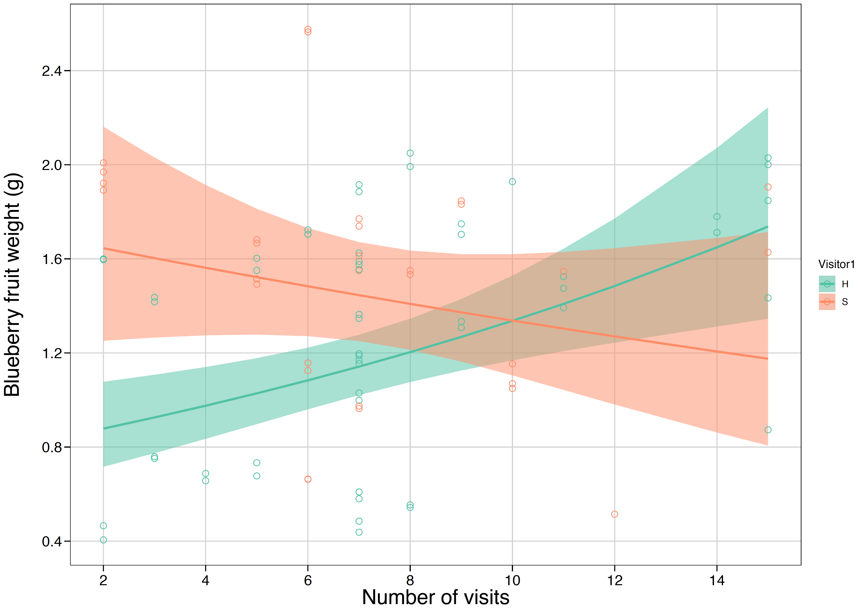

**Figure 1.** Weight of blueberry fruit from flowers first visited by a honeybee versus those first visited by a stingless bee. Solid lines are the model-estimated fruit weights with an increasing number of pollinator visits and shaded ribbons are the model-estimated confidence intervals. Hollow circles are the actual data.

However, we found no evidence of a pollinator priority effect in raspberry, where fruit weight was similar across the visit number range regardless of first visitor’s identity (honeybee – stingless bee slope contrast = 0.024 ± 0.035, *t* = 0.699, *P* = 0.48; Figure 2). The ratio of honeybee to stingless bee visits had no effect on fruit weight for both blueberry and raspberry.

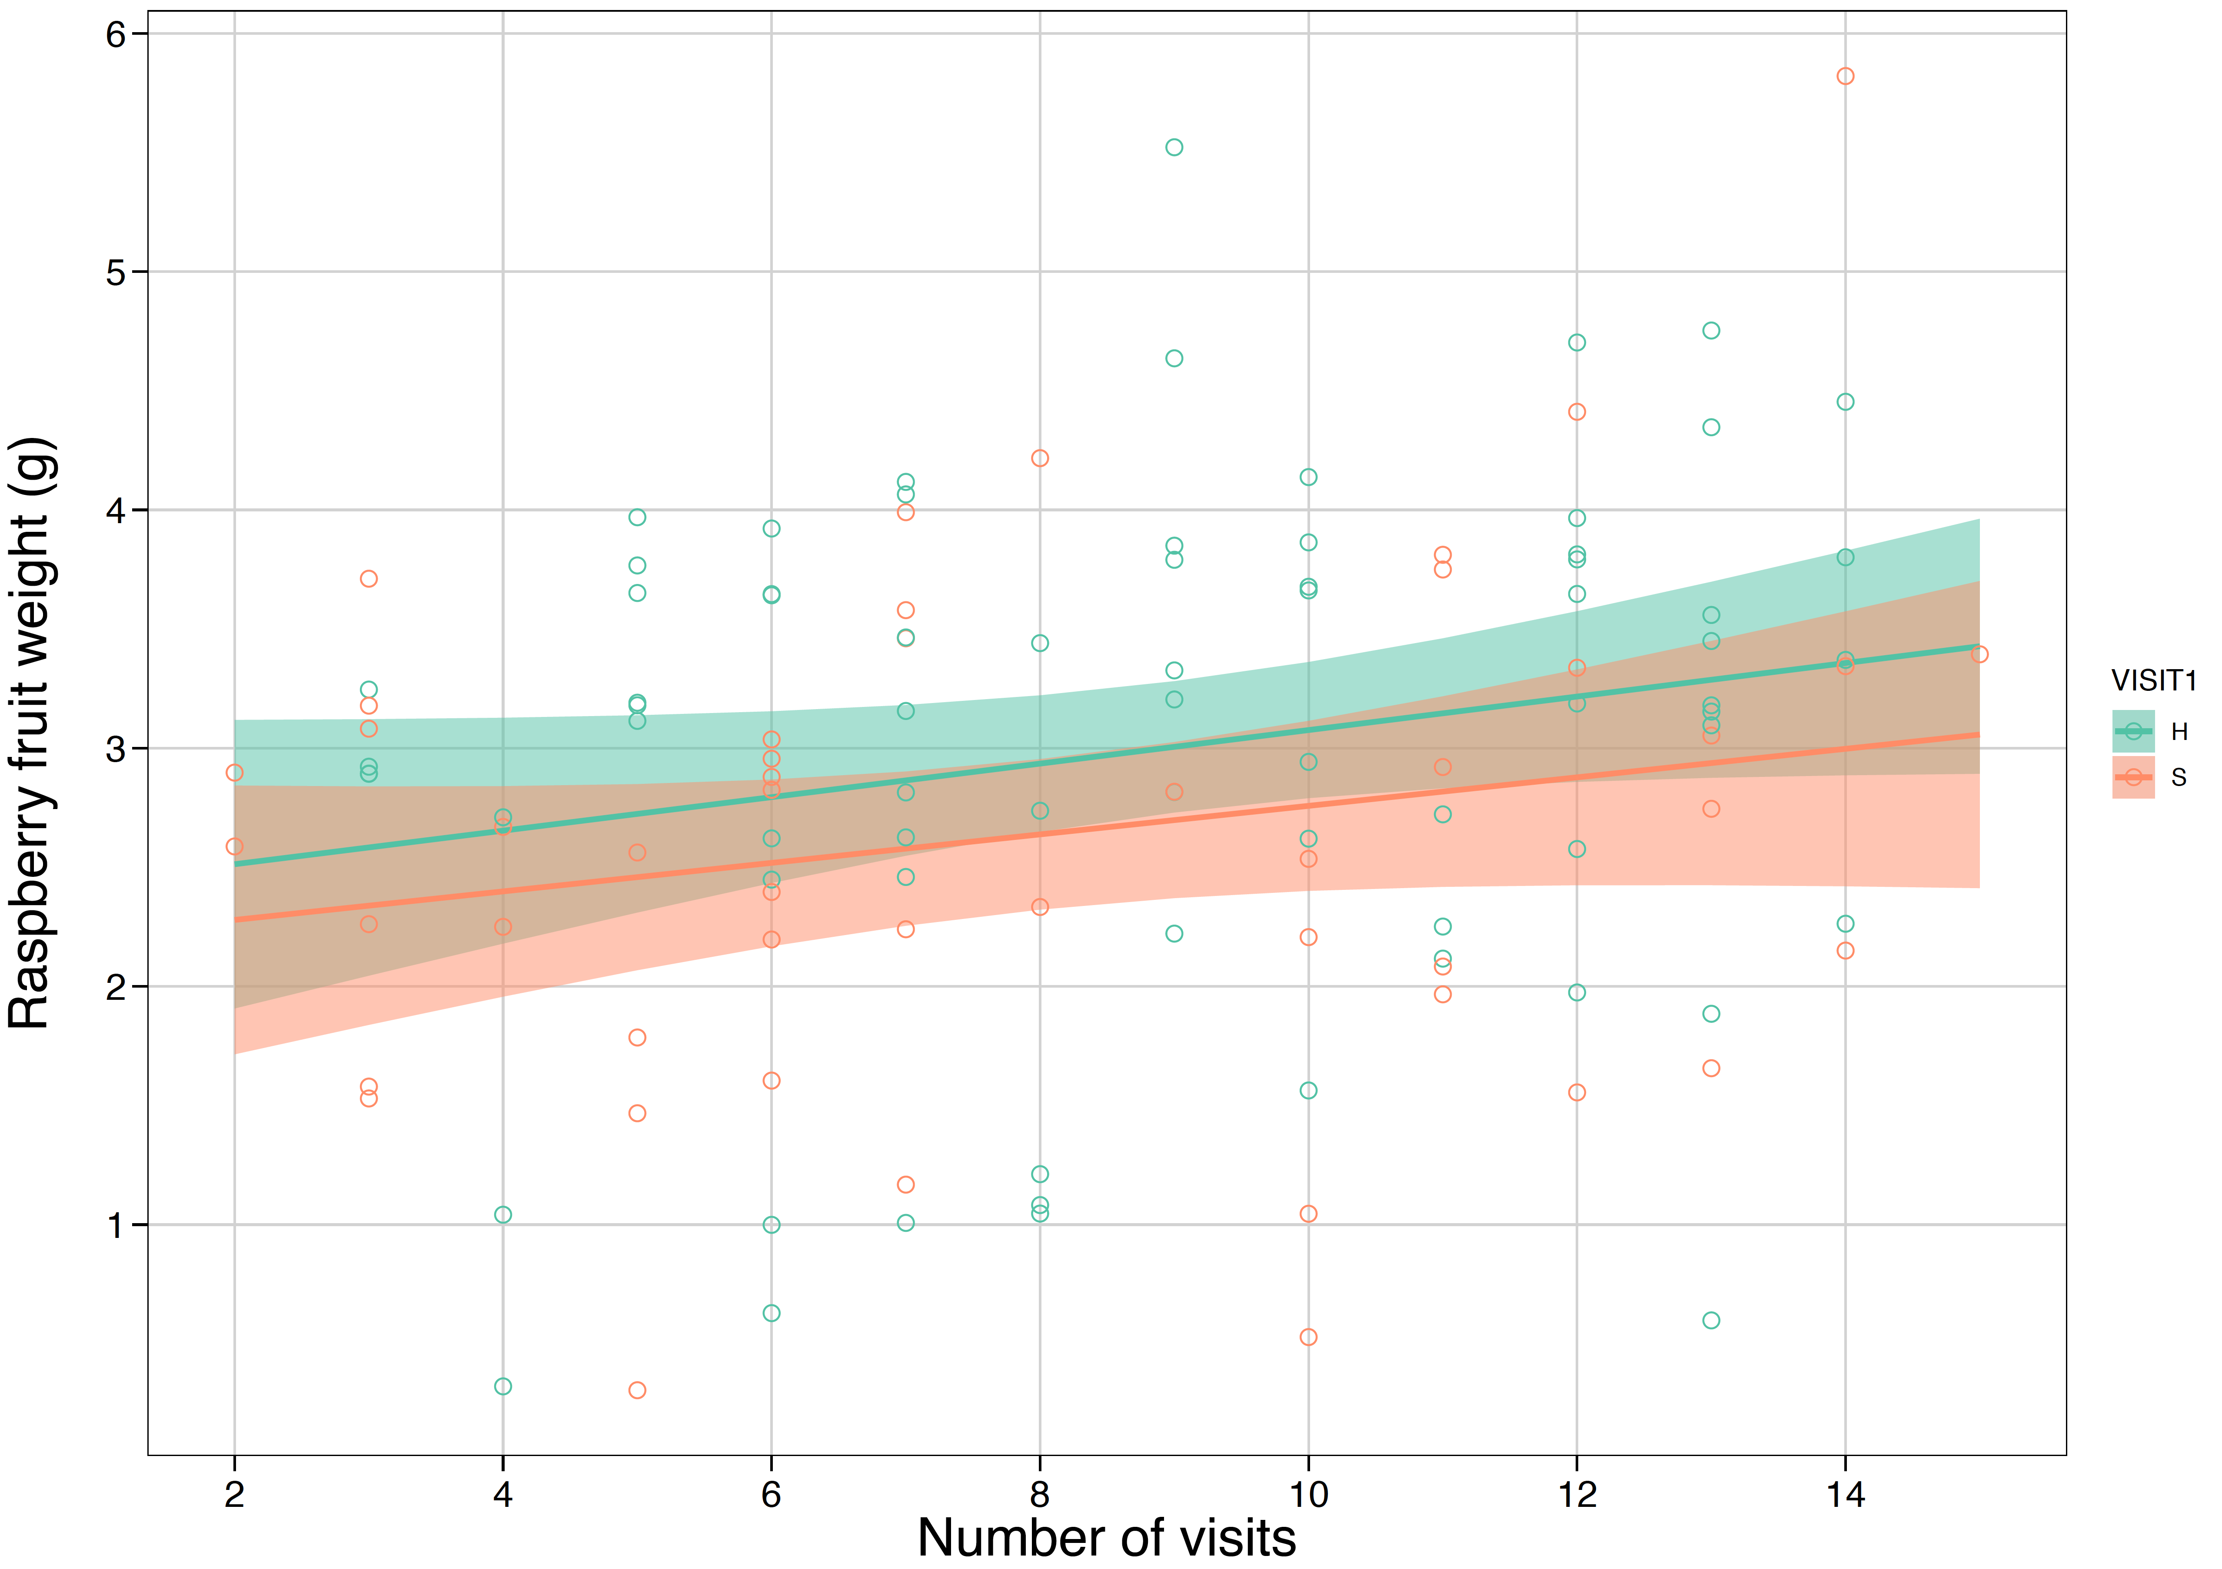

**Figure 2.** Weight of raspberry fruit from flowers first visited by a honeybee versus those first visited by a stingless bee. Solid lines are the model-estimated fruit weights with an increasing number of pollinator visits and shaded ribbons are the model-estimated confidence intervals. Hollow circles are the actual data.

**Does a mixture of floral visits from different pollinator species result in heavier fruits than visits from a single species?**

For blueberry, we found that fruit weight increased with an increasing number of visits from honeybees (slope = 0.108 ± 0.047, *z* = 2.285, *P* = 0.0118; Figure 3) and stingless bees combined with honeybees (slope = 0.028 ± 0.015, *z* = 1.852, *P* = 0.0329) but not for stingless bees only (slope = -0.029 ± 0.079, *z* = -0.385, *P* = 0.6496).

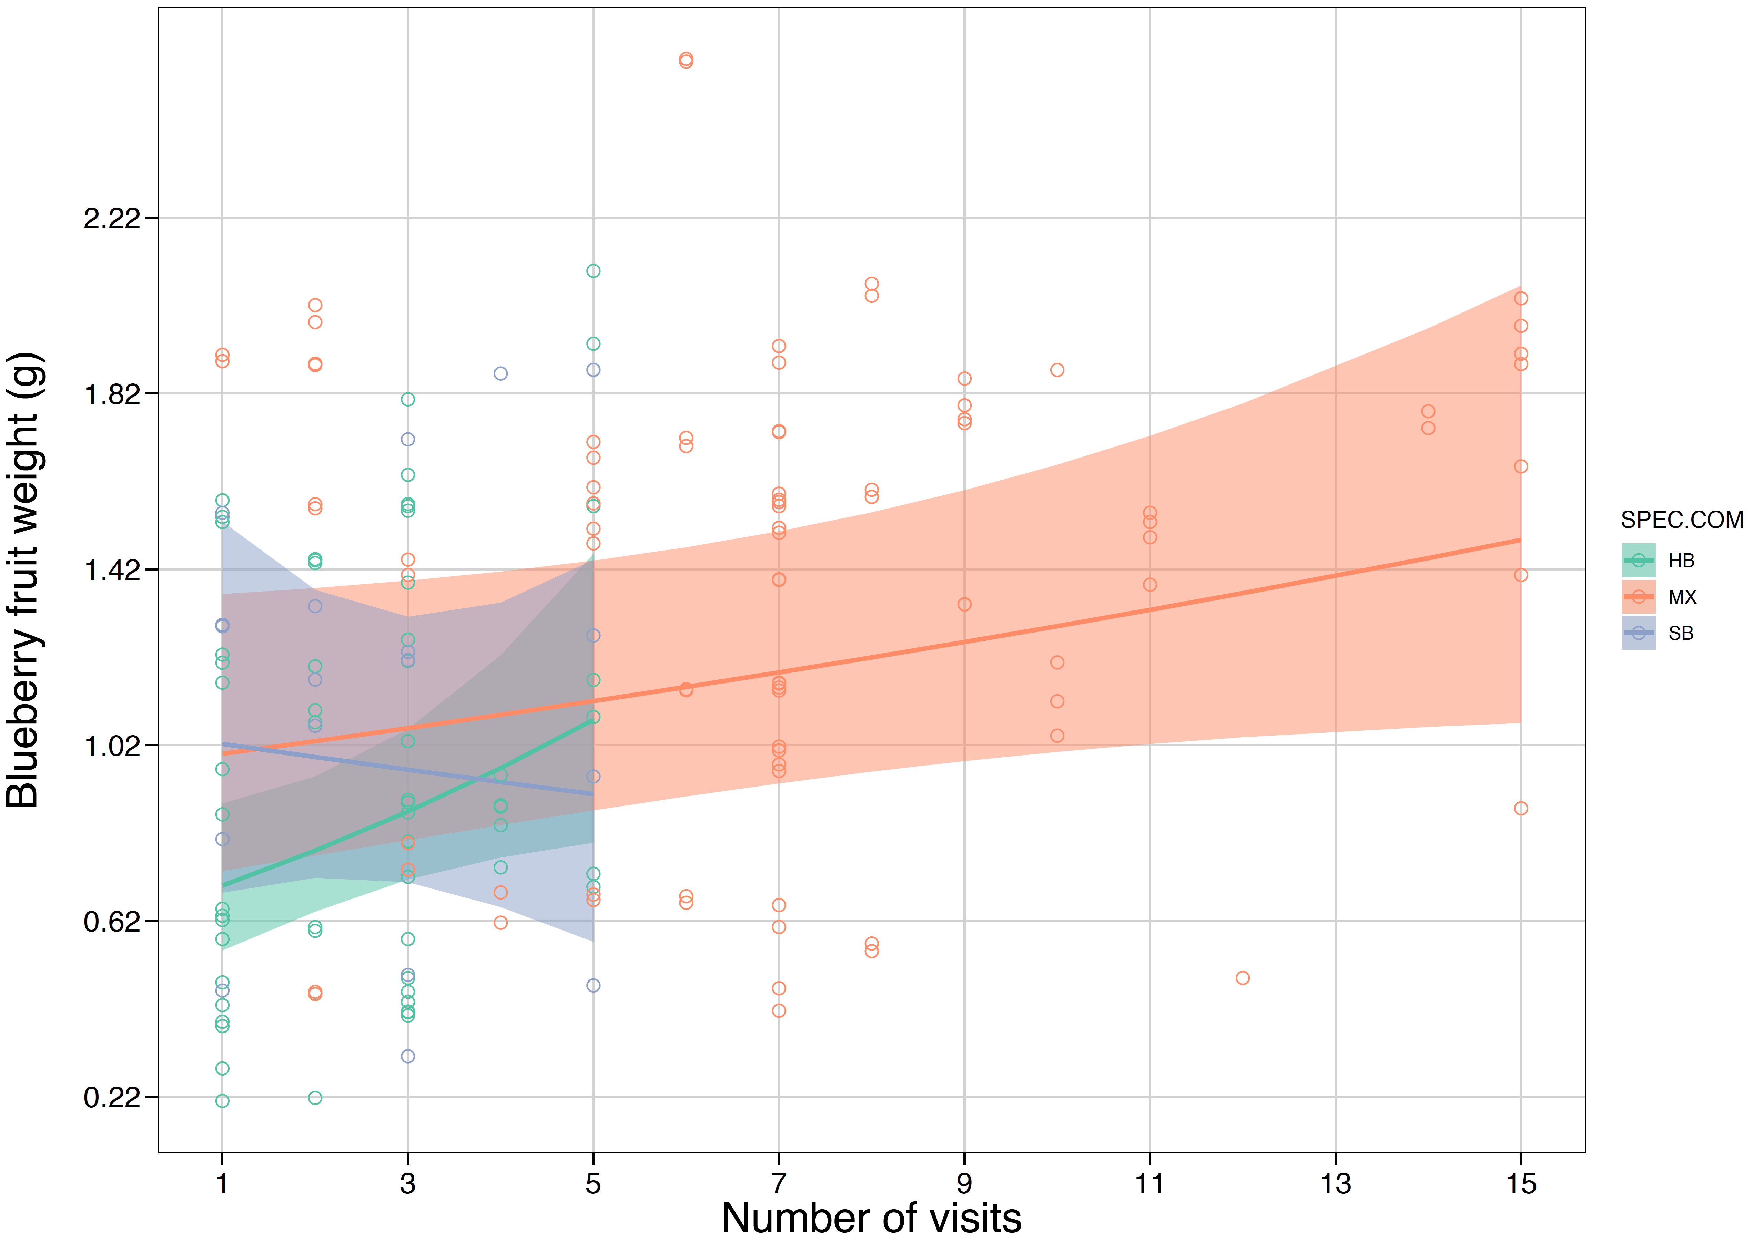

**Figure 3.** Weight of blueberry fruit from flowers visited by only honeybees or stingless bees or a mixture of honeybees and stingless bees. Solid lines are the model-estimated fruit weights with an increasing number of pollinator visits and shaded ribbons are the model-estimated confidence intervals. Hollow circles are the actual data.

In contrast, for raspberry, we found that fruit weight increased with an increasing number of visits from stingless bees (slope = 0.178 ± 0.069, *z* = 2.559, *P* = 0.006; Figure 4) and stingless bees combined with honeybees (slope = 0.043 ± 0.016, *z* = 2.657, *P* = 0.0042) but not from honeybees only (slope = 0.026 ± 0.029, *z* = 0.886, *P* = 0.1883).

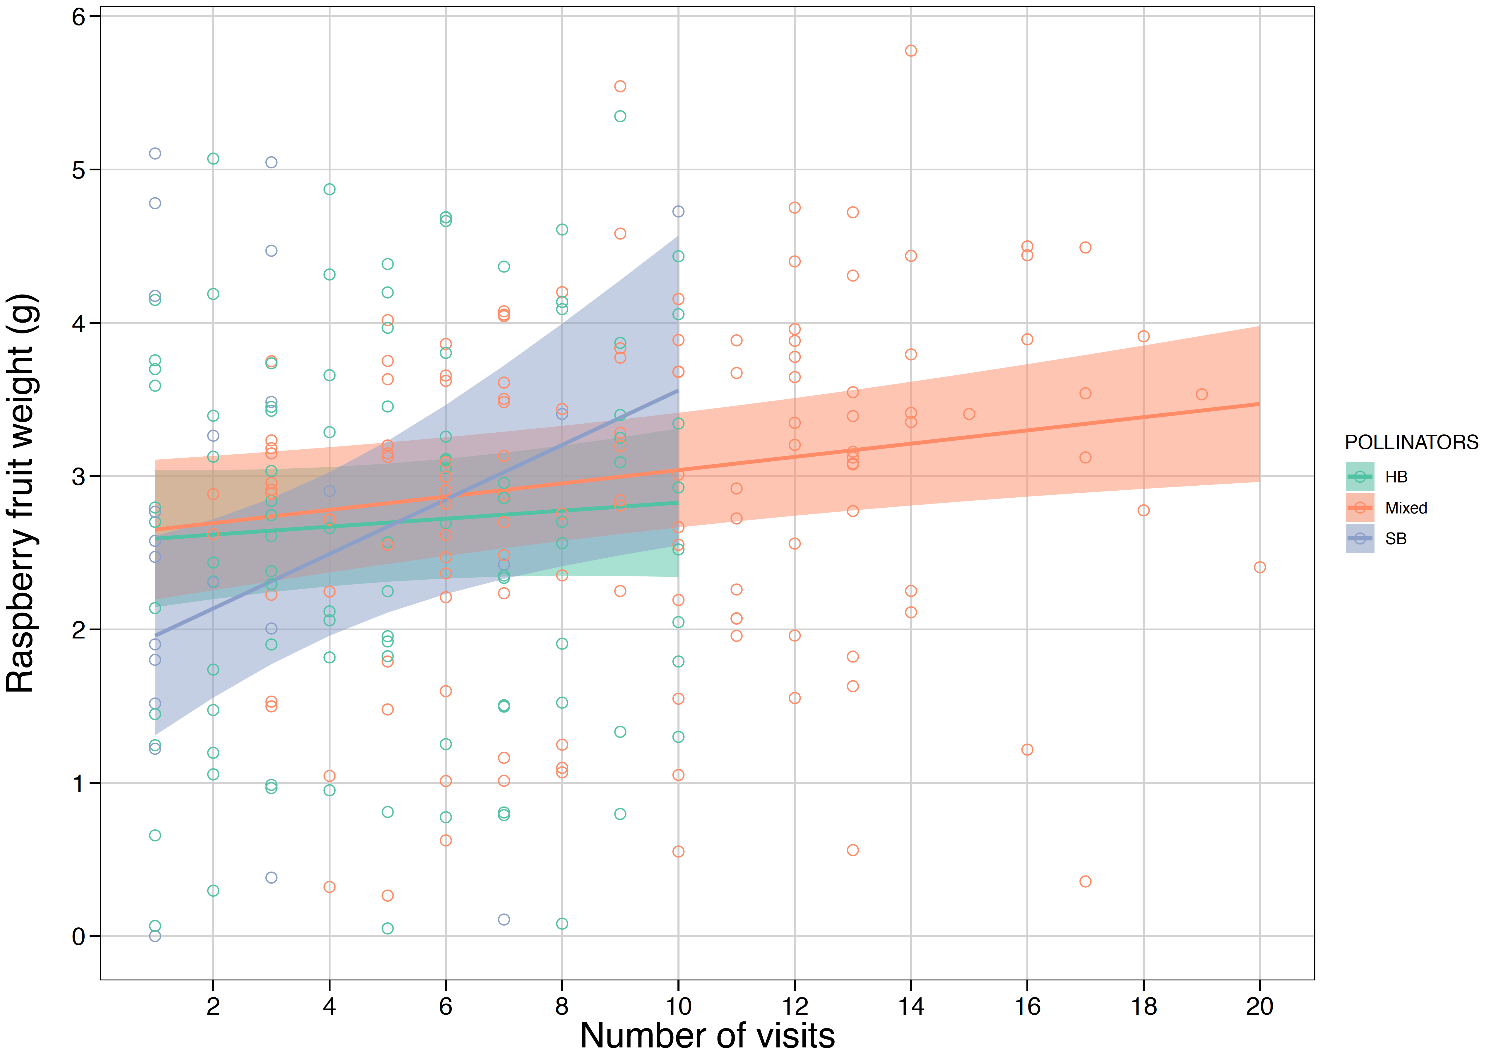

**Figure 4.** Weight of raspberry fruit from flowers visited by only honeybees or stingless bees or a mixture of honeybees and stingless bees. Solid lines are the model-estimated fruit weights with an increasing number of pollinator visits and shaded ribbons are the model-estimated confidence intervals. Hollow circles are the actual data.

Despite these trends, for both raspberry and blueberry we found no differences between slopes (association between fruit weight and the number of pollinator visits) for fruits produced from stingless bee versus honeybee visits. Similarly, there were no differences between slopes for fruits produced from a mixture of stingless bee and honeybee visits versus visits from either one of these taxa (Table SX).

**Discussion**

**Funding**

Jamie Stavert was funded by a University of New England post-doctoral fellowship.

**Author contributions**

LKK and RR conceived the study and designed the experiments. LKK and MH collected data. LKK, JS and VG analysed these data. LK and JS wrote the manuscript and all authors contributed substantially to the final version.

**Acknowledgements**

We thank Costa Group for allowing farm access to undertake this research. We are grateful to Greg Bible, Juan Garces, Jeremy Jones, Jeremy Kirkland, Lindsey Kirkland, Carmen Laidlaw and Annie Warren for help in the field.